Rock of Ages Baptist Church
2019 Bible Study & Small Growth Groups
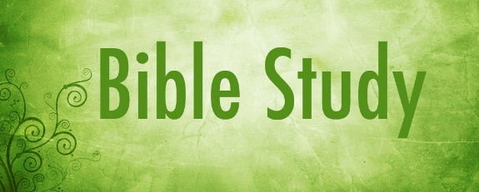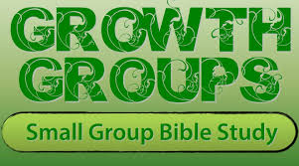
Spiritual growth does not happen automatically. Nor does it happen by accident. We must intentionally position ourselves for spiritual growth.
At Rock of Ages, our desire is to see everyone grow to spiritual maturity. Thus, we offer Bible Study and Small Growth Groups to help you build a stronger relationship with Christ and deepen your fellowship with others. Bible Study and Small Growth Groups are close-knit gatherings that meet at church, in homes, and other locations. Each class is held between 4 to 13 weeks during the Spring, Summer and Fall months each year.
We all need encouragement. We all need wise counsel. We all need a safe place to ask hard questions. We all need to hear one another’s testimonies. We all need to sharpen and BE sharpened. And Bible Study and Small Growth Groups are an outstanding opportunity to build that kind of fellowship with one another.
See the list of classes offered for 2019 below and make a decision to join us for Bible Study and Small Growth Group:
. 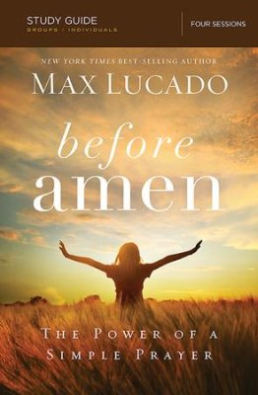
Session Length: 4 weeks
Classes Begins: Tuesdays, March 5, 2019 @ 7:00 p.m. (Varry Henderson, facilitator)
Classes Begins: Wednesdays, March 6, 2019 @ 12:30 p.m. (Deacon Standberry, facilitator)
Class Location: Rock of Ages Baptist Church

In Before Amen, Max Lucado, a self-professed "recovering prayer wimp," reveals his personal struggles with prayer. In this 4-week session he will show you how he discovered that prayer is not a privilege for the pious or the art of a chosen few but a simple tool all believers have been given to have a conversation with God. Max will lead you in building a prayer life that is stronger, better and deeper.
Before Amen, by Max Lucado study guide can be purchased online at christianbook.com for $6.49

.

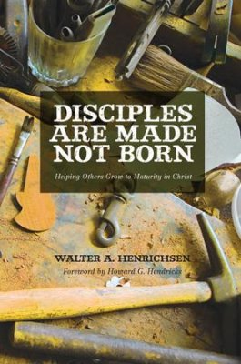
“Make Disciples" Jesus' command is clear. But what is a disciple? And how are we to "make" them? In this thirteen-week session of Disciples Are Made, Not Born, Walter A. Hendricksen, explains and illustrates the process of disciple-making that Jesus taught and modeled. While disciple-making is challenging, experience the fulfillment that comes from being faithful to the life mission to which God has called us---Christ's Great Commission.
Disciples Are Made, Not Born by Walter A. Hendricksen study guide can be purchased at christianbook.com for $11.99

.

Session Length: 13 weeks
Classes Begins: Tuesdays, April 2, 2019 @ 7:00 p.m. (Pastor Henderson, facilitator)
Classes Begins: Wednesdays, April 3, 2019 @ 12:30 p.m. (Deacon Standberry, facilitator)
Class Location: Rock of Ages Baptist Church

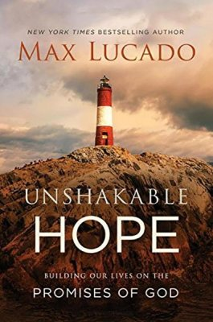
Session Length: 12 weeks
Classes Begins: July 2019
Class Facilitators*: Arlene Browden and Debra Cornell
*contact the facilitator to attend a class convenient for your schedule and location
Nothing lifts us out of fear and weariness like hope. An anchor through life's storms, hope buoys our spirits and seeks to make a way when we face tough times. In this twelve-week session Max Lucado of Unshakable Hope speaks to hurting hearts and shares the promises of God will give you the strength you need and equip you to face every day with courage.
Unshakable Hope, by Max Lucado study guide can be purchased at christianbook.com for $7.49

.

`
\\\

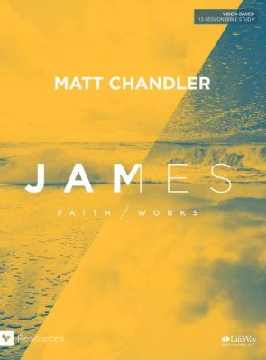
Session Length: 13 weeks
Classes Begins: July 2019
Class Facilitators*: Maoise Palmer and Deacon Standberry
*contact the facilitator to attend a class convenient for your schedule and location
We don't work to be saved; we work because we are saved. But without faith our works are empty service. And without works our faith is dead. In this 13-session Bible Study on the book of James, Matt Chandler teaches us that faith and works are not enemies; they are friends
James – Faith/Work, by Matt Chandler study guide can be purchased at LifeWay Christian bookstore for $12.99

.

`

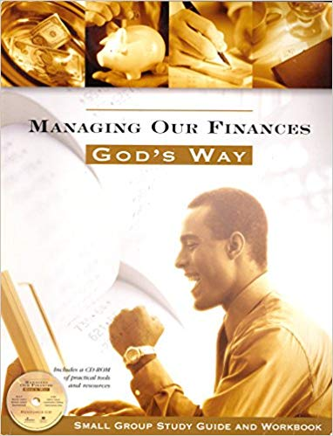
The Managing Our Finances God's Way shows youhow to live debt-free and glorify God with their money so they can experience joy in his blessings! God graciously gives us everything we have so we can partner with him to accomplish His good purposes on earth. And this dynamic small group study will help your church live out His plan for financial management — so you can experience his very best for their lives!
A sign-up sheet to attend and order the study guide for Managing Our Finances God’s Way will be made available.

.

`
Session Length: 7 weeks
Classes Begins: October 2019 (Saturdays)
Class Facilitator: Pastor Henderson
*Note: This is a church-wide session to be held on Saturdays at 10:30 a.m.

*contact the facilitator to attend a class convenient for your schedule and location

